Download the 2A/2B formula sheet from the Curriculum Council website to use with his exam.

Semester 1 Examination, 2010

Question/Answer Booklet

MATHEMATICS 2A
Section One:
Calculator-free

Time allowed for this section
Reading time before commencing work: 5 minutes
Working time for this section: 50 minutes

Material required/recommended for this section

To be provided by the supervisor
This Question/Answer Booklet
Formula Sheet

To be provided by the candidate
Standard items: pens, pencils, pencil sharpener, eraser, correction fluid, ruler, highlighters

Special items: nil

Important note to candidates
No other items may be used in this section of the examination. It is your responsibility to ensure that you do not have any unauthorised notes or other items of a non-personal nature in the examination room.


Ensure that your mobile phone is not in your possession, that it is turned to silent and that no alarms are on.

If you have any unauthorised material with you, hand it to the supervisor before reading any further.

Structure of this paper

Section | Number of questions available | Number of questions to be answered | Suggested working time  (minutes) | Marks available
Section One:  Calculator-free | 7 | 7 | 50 | 40
Section Two:  Calculator-assumed | 11 | 11 | 100 | 80
 |  |  |  | 120

Instructions to candidates

1. Write your answers in the spaces provided in this Question/Answer Booklet. Spare pages are included at the end of this booklet. They can be used for planning your responses and/or as additional space if required to continue an answer.
  - Planning: If you use the spare pages for planning, indicate this clearly at the top of the page.
  - Continuing an answer: If you need to use the space to continue an answer, indicate in the original answer space where the answer is continued, i.e. give the page number. Fill in the number of the question(s) that you are continuing to answer at the top of the page.

2. Show all your working clearly. Your working should be in sufficient detail to allow your answers to be checked readily and for marks to be awarded for reasoning. Incorrect answers given without supporting reasoning cannot be allocated any marks. For any question or part question worth more than two marks, valid working or justification is required to receive full marks. If you repeat an answer to any question, ensure that you cancel the answer you do not wish to have marked.

3. It is recommended that you do not use pencil except in diagrams.
USE BLUE OR BLACK PEN.

Marks Analysis
Question Number | Marks available | Marks awarded
1 | 8
2 | 8
3 | 5
4 | 7
5 | 2
6 | 4
7 | 6
Total | 40

Section One: Calculator-free (40 Marks)

This section has seven (7) questions. Answer all questions. Write your answers in the space provided.

Spare pages are included at the end of this booklet. They can be used for planning your responses and/or as additional space if required to continue an answer.
  - Planning: If you use the spare pages for planning, indicate this clearly at the top of the page.
  - Continuing an answer: If you need to use the space to continue an answer, indicate in the original answer space where the answer is continued, i.e. give the page number. Fill in the number of the question(s) that you are continuing to answer at the top of the page.

Suggested working time for this section is 50 minutes.

Question 1 (8 marks)

Solve algebraically for each unknown.

(a) (2 marks)

(b) 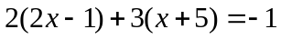 (2 marks)

(c) 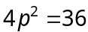 (2 marks)

(d) 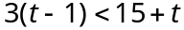 (2 marks)

Question 2 (8 marks)

(a) Expand and simplify 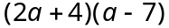 (2 marks)

(b) Factorise 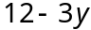 (1 mark)

(c) Write in algebra using usual conventions: (1 mark)
"A number has five added to it and the result is multiplied by eight".

(d) Lolita purchases a travel bag. The usual price is $60. There is a discount of 20% in a sale. What amount does Lolita pay? (1 mark)

(e) Evaluate 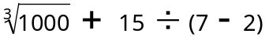 (2 marks)

(f) Michael Douglas lost two-thirds of his fortune in the global financial crisis (GFC). He originally had assets worth $120 000 000 . What were his assets worth after the GFC?
(1 mark)

Question 3 (5 marks)

(a) A survey of a housing development site has been conducted and a field sketch (not to scale) of the roads made as shown. An underground power cable will run in a straight line from A to B. (2 marks)

50 m
350 m
300 m
A
B

What is the length of the power cable?

(b) Three friends combine to make a syndicate to buy one $20 lottery ticket. Jake paid $10, Millie paid $4 and $6 was paid by Ahmed. The tickets wins third prize of $8 000 and is to be shared between the three friends in proportion to what they paid to be in the syndicate. How much of the prize money will each friend receive? (2 marks)

(c) The mean weight of 10 people is 73.4 kg. What is the total weight of the ten people?
(1 mark)

Question 4 (7 marks)

(a) Consider the shape A and its images B and C shown below.

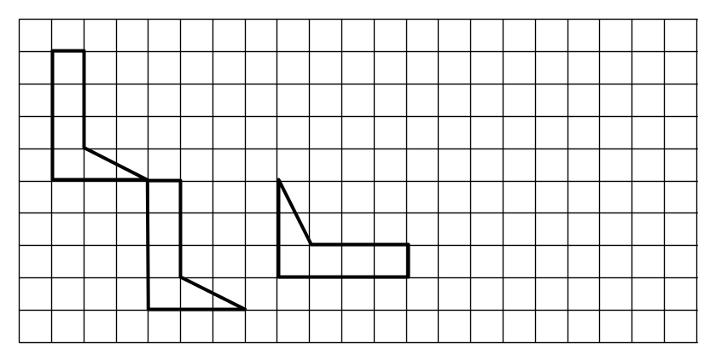
A
B
C

(i) Describe a single transformation of shape A that will create its image B. (1 mark)

(ii) Describe a series of two transformations of shape A that will create its image C.
You may mark on the grid to assist your explanation. (2 marks)

(b) For the shapes below, describe a series of transformations that would create image E from shape D. You may mark on the grid to show working. (2 marks)

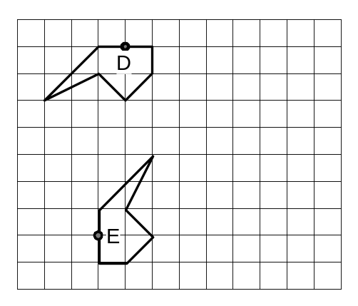
(c) On the diagram, draw the image of the shape at the end of this series of transformations. Sketch each step and clearly label the final image. (2 marks)

step 1: reflect in the line AB

step 2: translate 6 units to the right and 4 units up

step 3: rotate 180° about point T in an anti-clockwise direction.

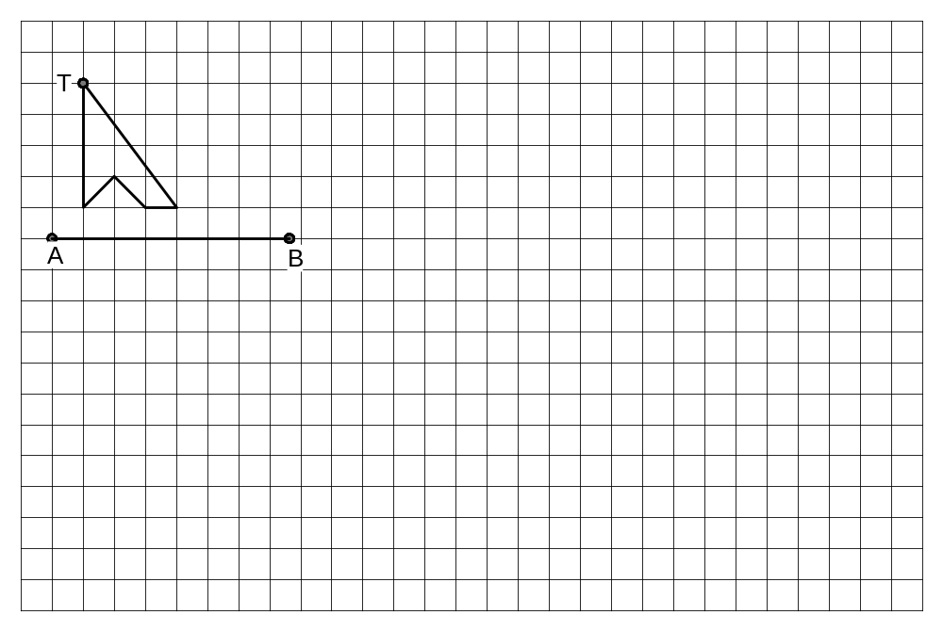

Question 5 (2 marks)

Determine the value of and in the following sketch graphs.



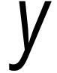
(0,8)
(3,6)
(
, 0)
(3,
)
(0,5)
(5, 0)

(a) (b)

Question 6 (4 marks)

Petra needs to estimate the height of the flagpole to ensure the new rope for raising the flag is long enough. On a sunny day, she places a 1 metre ruler next to the flag pole while her friends measure the length of the shadow of both the ruler and the flagpole. See the sketch (not drawn to scale) below.

ruler
flagpole
The shadow of the flagpole measured 320 cm at the same time that the shadow of the ruler measured 25 cm.

(a) Estimate the height of the flagpole using the measurements that Petra obtained.
(2 marks)

(b) The rope for the flag needs to be approximately twice as long as the height of the flagpole. How much rope, to the nearest metre, should Petra purchase. (2 mark)

Question 7 (6 marks)

(a) The level of water usage of 200 houses was rated in a survey as low, medium or high and the size of the houses as small, standard or large. The results of the survey are displayed in the table below.
 |  | Size of house
 |  | Small | Standard | Large | Total
Level of water usage | Low |  | 8 | 3 | 21
Level of water usage | Medium | 23 | 64 | 8 | 95
Level of water usage | High | 17 | 32 |  | 84
 | Total | 50 | 104 | 46 | 200

(i) Complete the table. (1 mark)

(ii) How many houses in the survey were large? (1 mark)

(iii) What fraction, in simplest terms, of small houses in the survey had low water usage? (1 mark)

(iv) What is the percentage of standard size houses in the survey? (1 mark)

(b) A souvenir shop sells four sizes of T-shirts. From years of sales, the owner knows that sales are made in the relative frequency shown in the table below.

Size | Small | Medium | Large | Extra large
Sales | 0.1 | 0.45 |  | 0.15

(i) Complete the table. (1 mark)

(ii) The shop owner orders 400 T-shirts in the same proportions as shown in the table. How many Extra Large size T-Shirts should be delivered? (1 mark)

End of questions
Additional working space

Question number(s): __________

